|  |  |
| --- | --- |
| Document Title | Specification of ULTRASONIC Driver |
| **Document Owner** |  |
| **Document Responsibility** | Yasmin Mohamed Alaa Al-Din |
| **Document Identification No** |  |
| **Document Classification** |  |
|  |  |
| **Document Version** |  |
| **Document Status** |  |
| **Part of Release** |  |
| **Revision** |  |

|  |  |  |  |
| --- | --- | --- | --- |
|  | **Document Change History** | | |
| **Date** | **Version** | **Changed by** | **Change Description** |
| 20.04.2017 | 1.0.1 | Yasmin Mohamed Alaa Al-Din | Adding state machine |
| 20.04.2017 | 1.0.0 | Yasmin Mohamed Alaa Al-Din | Initial Release |

**Disclaimer**

This specification and the material contained in it is for the purpose of information only. The companies that have contributed to it shall not be liable for any use of the specification.

The material contained in this specification is protected by copyright and other types of Intellectual Property Rights. The commercial exploitation of the material contained in this specification requires a license to such Intellectual Property Rights.

This specification may be utilized or reproduced without any modification, in any form or by any means, for informational purposes only.

For any other purpose, no part of the specification may be utilized or reproduced, in any form or by any means, without permission in writing from the publisher.

**Table of Contents**

Contents

1 Introduction and functional overview 5

1.1 Objective 5

1.2 Context Diagram 5

1.3 Acronyms and abbreviations 5

2 External interfaces 6

2.1 Std_Types.h 6

2.1.1 Types 6

2.1.2 Interfaces 6

2.1.3 Constants 6

2.1.4 Variables 6

2.2 ICU_MCAL.h 6

2.2.1 Types 6

2.2.2 Interfaces 6

2.2.3 Constants 7

2.2.4 Variables 7

2.3 DIO.h 7

2.3.1 Types 7

2.3.2 Interfaces 7

2.3.3 Constants 7

2.3.4 Variables 7

3 Static Design 7

3.1 File structure 7

3.1.1 Used Files 7

3.1.2 File inclusion 8

3.2 Types 8

3.2.1 Imported types 8

3.2.2 Types Definitions 8

3.3 Symbol Definition 9

3.4 Function definitions 9

3.4.1 9

3.5 Call-back notifications 10

3.6 Scheduled functions 10

4 Dynamic Design 10

4.1 Mode Management 11

4.2 Sequence Diagram 11

4.2.1 Trigger mode 11

5 Shared Resources 12

6 Configuration specification 12

6.1 Containers and configuration parameters 12

6.1.1 Variants 12

6.1.2 Parameters 12

7 Configuration Constraints 13

8 Integration Constraints 13

9 History 13

9.1 Initial version 13

9.2 Any update for ULTRASONIC_CDD will determine in this section. 13

# Introduction and functional overview

## Objective

It’s used for calculating distance between object and ultrasonic sensor using ICU in timer1

## Context Diagram

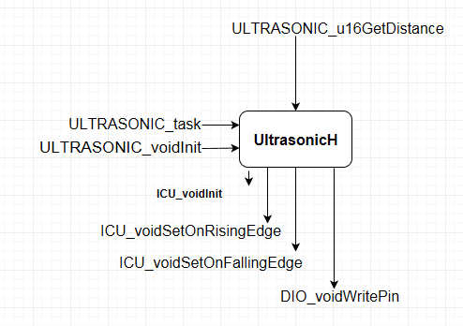

## Acronyms and abbreviations

Acronyms and abbreviations that have a local scope.

|  |  |
| --- | --- |
| ***Abbreviation / Acronym:*** | ***Description:*** |
| ICU | Input capture unit |

# External interfaces

## Std_Types.h

### Types

|  |  |
| --- | --- |
| Name | Description |
| U8 | Unsigned char. |
| U16 | Unsigned short Int. |
| U32 | Unsigned long Int. |

### Interfaces

None

### Constants

None.

### Variables

None.

## ICU_MCAL.h

### Types

None

### Interfaces

|  |  |
| --- | --- |
| Name | Description |
| **Void ICU_voidInitialize(void)** | This function initiates all register which related to the ICU module |
| Void ICU_voidSetOnRisingEdge(void) | This function shall enable the ICU interrupt on rising edge |
| Void ICU_voidSetOnFallingEdge(void) | This function shall enable the ICU interrupt on falling edge |
| **Void ICU_voidEnableInterrupt(void)** | This function shall enable the ICU interrupt |
| **Void ICU_voidDisableInterrupt(void)** | This function shall disable the ICU interrupt |

### Constants

None.

### Variables

None.

## DIO.h

### Types

|  |  |
| --- | --- |
| Type | ***Description*** |
| DIO_pin_Name_t | Enum has the names of the pins used in the DIO |

### Interfaces

|  |  |
| --- | --- |
| Function | ***Description*** |
| DIO_writePin | This function is used to write on a specific pin |

### Constants

None

### Variables

None

# Static Design

## File structure

### Used Files

|  |  |
| --- | --- |
| ***File*** | ***Description*** |
| UltrasonicSensor.h | This file includes all prototype of function, #defines, extern constant, types which will be accessible to the other modules. |
| UltrasonicSensor.c | Contains the implementation of all the interfaces of the Ultrasonic interfaces. |

### File inclusion

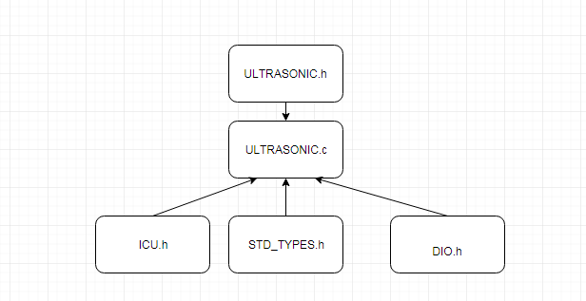

## Types

### Imported types

|  |  |
| --- | --- |
| ***Module*** | ***Imported Type*** |
| STD_TYPES.h | U8 |
| U16 |
| U32 |

|  |  |
| --- | --- |
| ***Module*** | ***Imported Type*** |
| DIO.h | U8 |
| U16 |
| U32 |

### Types Definitions

|  |  |  |  |
| --- | --- | --- | --- |
| ***Name:*** |  | | |
| ***Type:*** |  | | |
| ***Range:*** |  |  |  |
| ***Description:*** |  | | |

## Symbol Definition

|  |  |
| --- | --- |
| ***Name:*** |  |
| ***Type:*** |  |
| ***Value:*** |  |
| ***Description:*** |  |

## Function definitions

This is a list of functions provided for upper layer modules.

### 

|  |  |  |
| --- | --- | --- |
| ***Service name:*** | **Ultrasonic_voidInit** | |
| ***Syntax:*** | **voidULTRASONIC_voidInit(void)** | |
| ***Service ID[hex]:*** | Ultrasonic-001 | |
| ***Sync/Async:*** | Sync | |
| ***Reentrancy:*** | None | |
| ***Parameters (in):*** | None |  |
| ***Parameters***  ***(in/out):*** | None | |
| ***Parameters (out):*** | None | |
| ***Return value:*** | None |  |
| ***Description:*** | This function initiates all modules which related to the Ultrasonic module | |

|  |  |  |
| --- | --- | --- |
| ***Service name:*** | **Ultrasonic_u16GetDistance** | |
| ***Syntax:*** | Void **Ultrasonic_u16GetDistance**(void) | |
| ***Service ID[hex]:*** | Ultrasonic -002 | |
| ***Sync/Async:*** | Sync | |
| ***Reentrancy:*** | None | |
| ***Parameters (in):*** | None |  |
| ***Parameters***  ***(in/out):*** |  | |
| ***Parameters (out):*** | None | |
| ***Return value:*** | U16 | This value represents distance between ultrasonic sensor and object |
| ***Description:*** | This function shall get the value of duration time of pulse generated by echo pin using ICU module and then use it in a specific equation to calculate distance and return that value to caller | |

## Call-back notifications

The Ultrasonic module does not provide any callback notifications.

## Scheduled functions

The Ultrasonic module has no scheduled functions.

# Dynamic Design

## Mode Management

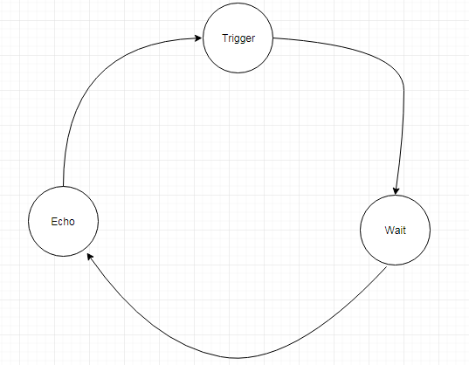

## Sequence Diagram

### Trigger mode

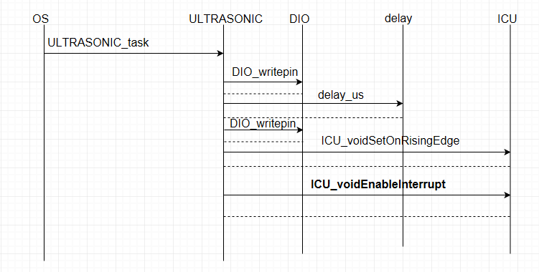

# Shared Resources

There are no shared resources between ICU module and other modules.

# Configuration specification

This chapter defines configuration parameters and their clustering into containers.

## Containers and configuration parameters

The following chapters summarize all configuration parameters.

### Variants

Configuration variants describe sets of configuration parameters:

* VARIANT-PRE-COMPILE (PC)

Only parameters with "Pre-compile time" configuration are allowed in this variant.

* VARIANT-LINK-TIME (LT)

Only parameters with "Pre-compile time" and "Link time" are allowed in this variant.

* VARIANT-POST-BUILD (PB)

Parameters with "Pre-compile time", "Link time" and "Post-build time" are allowed in this variant.

Parameters

### 

### Parameters

#### 

|  |  |  |  |
| --- | --- | --- | --- |
| ***Name*** |  | | |
| ***Description*** |  | | |
| ***Multiplicity*** | 1 | | |
| ***Type*** |  | | |
| ***Default value*** | -- | | |
| ***Configuration Class*** | ***Pre-compile time*** | | |
| ***Configuration Class***  ***Scope / Dependency*** | ***Link time*** | X | All Variants |
| ***Post-build time*** | -- |  |
| scope: local | -- |  |
|  |  | | |

# Configuration Constraints

There is no configuration need for ULTRASONIC module until any update.

# Integration Constraints

Initialization function is required to use the ULTRASONIC module.

# History

## Initial version

## Any update for ULTRASONIC_CDD will determine in this section.